

Software quality engineering test   
 plan

Blood Bank Management System

Abstract

This is test plan for the blood bank management system that we have prepared for our software construction and development course. This includes the planning activities outlined in the template provided. The group members are Munir Abbasi, Mustafa Zahid, and Raza Ali.

# Contents

1.0. Purpose. 2

2.0. Features to be tested. 3

3.0. Features not to be tested. 3

4.0. Suspension criteria and resumption criteria 3

5.0. Environmental needs 4

6.0. Schedule 5

7.0. Acceptance Criteria 5

7.1. Functional Quality 6

7.2. Structural Quality 6

7.3. Process Quality 6

7.3.1. Static Testing. 7

7.3.2. Dynamic Testing. 7

8.0. Role and Responsibilities 7

# 1.0. Purpose.

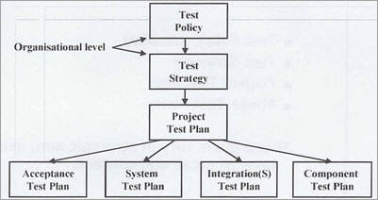

The purpose of the test plan is to ensure that the software developed is such that it we are able to completely outline and identify the test descriptions such as the objectives of our quality assurance, design specifications, test case specifications and then also test the implementations of the software. The test plan will help is identify and test the software while outlining the validation techniques for the software as well. We have to ensure that our software is up to ISO standards and such that the documentation is written so our team can work well together as well. Every member will be aware of the requirements that we have to meet as well.

# 2.0. Features to be tested.

As per the criteria outlined by the course instructor, we are going to be performing testing on 5 major test scenarios. Each scenerio will have their own test suites.

1. User can create an account.
2. User can login to account.
3. Admin can login to account.
4. Admin can delete donor.
5. Admin can manage stock.
6. Admin can change stock.
7. Admin can view requests for blood.
8. Admin can accept requests.
9. User can contribute money.
10. User can request blood.
11. User can donate blood.
12. User can search for blood.
13. User can search for hospitals.
14. Admin can add a donor.
15. Admin makes a new hospital.

# 3.0. Features not to be tested.

* The about us page will not be tested.

# 4.0. Suspension criteria and resumption criteria

The criteria for suspension or resumption for a test case is such. The criteria of our software is rather simple. The test cases that will pass will be accepted. The passing will only be accepted when all of the steps are executed in the script which ensure that the complete test suite is successful.

We have additional criteria’s which when achieved ensure that the testing can be suspended:

* The scripts per step take no more than 5 minutes to execute.
* In the case of a warning, the step must be re-executed. If the warning is removed proceed, if not then try to remove the cause of the warning.
* In case of cross browser testing, run the scripts sequentially so the script monitoring is of better quality.
* Make sure that the outputs are not only matching but correct.
* Complete success should be achieved to maintain quality.
* Data integrity should be maintained and data conversion must be achieved as well.

# 5.0. Environmental needs

The needs of the working environment for the automated tool and the software will include:

* Eclipse IDE 2022 needs to be installed and have the most recent version. Additionally, Apache Tomcat Version 9.0.1 needs to be installed to ensure execution of the software on the host.
* MySQL Workbench with MySQL database version 8.0.0 installed, MySQL Command Line 4.5.1.6. We will be using the MySQL database as the backend container for storage.
* Katalon Studio 8.4.0 must be installed.
* The software and testing tool are operable are operable on all operating systems.
* The hardware set up preferred for the software is rather achieved by almost all modern computer systems.
* Katalon works on both Windows and Mac operating systems. For Katalon Studio, the recommended specifications are: a 2 GHz processor, 4 GB of RAM, and 1GB of Hard disk space.

# 6.0. Schedule

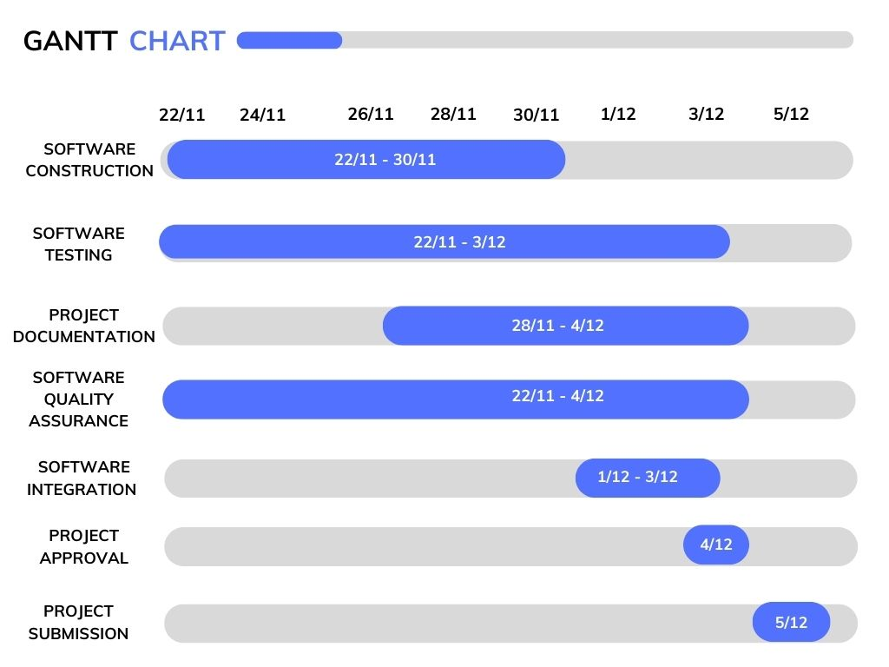

Even though the testing has been going on from over a week. The schedule outlined will begin from 22/11/2022 for the sake of the day this plan was developed. We will be submitting our project by the 5/12/2022.

# 7.0. Acceptance Criteria

The acceptance criteria for our software will be based on three major parts of the software development lifecycle.

## 7.1. Functional Quality

We plan to achieve functional quality by making sure that the functions of the software will:

1. Meet user requirements. We will provide achievable functionalities and bridge the formality gap between the user and the software. This will be ensured by successful implementations of functions and immediate feedback.
2. Reduce the defects in the software. Warnings and bugs will be corrected during software construction to make sure that the performance, security, and reliability are not compromised.
3. Provide an ease of use. The UI will be simple and we will apply Schneiderman’s 8 rules and Norman’s 7 principle to ensure the best human computer interaction.

## 7.2. Structural Quality

We will also ensure structural quality in the code to make sure that quality parameter is also met. We will ensure

* Code efficiency.
* Code understandability.
* Code testability.
* Code security.
* Code maintainability.

## 7.3. Process Quality

We will also make sure that we achieve process quality. We are already achieving this is certain ways such as following the best software construction process by planning and preparing the best solutions.

### 7.3.1. Static Testing.

We are incorporating static testing by performing peer programming. We are carrying out inspections to ensure quality.

### 7.3.2. Dynamic Testing.

Black box testing and white box testing will be incorporated with each bringing their own benefits for functional testing.

## 7.4. General Quality

* End user experience is at an agreed level.
* Successful completion of all tasks as mentioned in SRS.
* All previous defects cleared.
* Procedures have been drafted up for system setup, error recovery, and installation.
* Installation scripts and documents are tested.

## 7.5. Utilized testing techniques

Some utilized testing techniques are :

* Domain Analysis (For Donations Function)
* Use Case Testing (For all of the Functions)
* Decision Table Testing (For Login, accept and delete)
* WebUI Automation Testing

# 8.0. Role and Responsibilities

The roles and responsibilities are divided as such.

Raza Ali will be providing the software quality engineering principles while heading the project. He will be the project manager.

The software construction will be carried out by Munir Abbasi due to his experience in constructing similar software such as their dairy farm management system. He will be responsible for following standards that make sure that the construction phase achieves quality.

The backend record management will be carried out by Mustafa Zahid. He is a seasoned backend engineer whose interest in database engineering prompted his interest in the project. The non-functional attributes will be achieved here such as scalability etc. and his expertise will ensure that quality is assured as the consequence will be maximally achieved from here.